1. For the ERD in Figure 1, you should indicate applications of the identifying relationship rule. For each identifying relationship rule application, you should indicate the changes to the tables you listed in problem 2.

Solution:

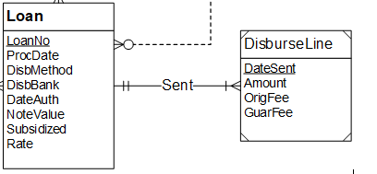

PK will be a combination of both Primary Keys:

Disburse Line(Data Sent, LoanNo, Amount, OrigFee, GuarFee)

FOREIGN KEY (LoanNo) REFERENCES Loan NOT NULL